**Departmental Reporting** *(updates made to text and video links below)*

Our Departmental Reporting demo highlights LOB-focused data and the ability for Analysts to scale up CPUs in ADW to optimize query performance. This demo runs on the NA Information Management tenancy – please request SE help to deliver a demo, lead a workshop, or for technical demo support.

Our Departmental Reporting demo also aligns with a set of marketing assets and LOB DVA files that you can leverage and upload to OAC or DVD to demonstrate the value of Oracle solutions to LOB analysts and business managers. Scroll down to access these additional assets. *(Users need to be able to see/access the LOB demo material from this page as well)*

| **Asset** | **Link** |
| --- | --- |
| Demo Videos | [Departmental Reporting on OTube](https://otube.oracle.com/media/t/1_4ep9x793) and [YouTube](https://www.youtube.com/watch?v=LoLaYKQNjHg);  [Oracle ADW Demo](https://video.oracle.com/detail/video/5758623251001) |
| Reference Architecture | [PPT](https://stbeehive.oracle.com/content/dav/st/NATD%20Autonomous%20Solution%20Demos/Public%20Documents/Departmental%20Reporting/Autonomous_Dept%20Reporting_notional%20architecture.pptx) |
| Demo Overview Presentation | [PPT](https://stbeehive.oracle.com/content/dav/st/NATD%20Autonomous%20Solution%20Demos/Public%20Documents/Departmental%20Reporting/Demo%20Package/Autonomous%20Solutions_Dept%20Reporting%20Demo%20Presentation.pptx) |
| Watch an SE Deliver the Demo | [Internal Video](https://otube.oracle.com/media/t/1_f809aroo) |
| For SEs - Demo Script | [DOCX](https://stbeehive.oracle.com/content/dav/st/NATD%20Autonomous%20Solution%20Demos/Public%20Documents/Departmental%20Reporting/Demo%20Package/Departmental%20Reporting%20Demo%20Script%20and%20Click%20Path.docx) |
| For SEs - Hands-On Workshop | *Coming soon* |

| **Target Customers, Offer Kits, and Value** |
| --- |
| Business Pain: | I am trying to create a visualization and the response speed is so slow. |
| Who to Target: | LOB VPs and Analysts including Marketing, Finance, Operations, Supply Chain |
| How to Position | [OTube Video(Internal)](https://otube.oracle.com/embed/secure/iframe/entryId/0_p7xic3pw/uiConfId/43012852) |
| Products Used: | [Oracle Autonomous Data Warehouse](https://cloud.oracle.com/en_US/datawarehouse), [Oracle Analytics Cloud](https://cloud.oracle.com/en_US/oac) |

Value Proposition:

* Quickly and easily scale up CPUs in the Autonomous Data Warehouse to optimize query speed and receive refreshed reports in seconds
* High performance and fully on-line - users are able to query with no service interruptions
* Built-in Analytics with interactive dashboards
* Machine Learning for advanced insights and visualizations

**Line of Business Demos (***content to be accessed via the Dept Reporting page and/or when a user clicks on the LOB demo link from the home page)*

The Line of Business demos provide a full set of assets and DVA files that can be accessed from the links below or from Sales Central. These align with the Departmental Reporting ADW demo, and allow users to leverage and upload these data sets to OAC or DVD to demonstrate the value of Oracle solutions to LOB analysts and business managers.

* Take Control of Your Data and Analytics with Autonomous Data Warehouse – full set of customer facing marketing videos, scripted demos and DVA/Excel files by LOB highlighting the power and value of ADW for analysts *(takes users to first 2 tables below)*
* Line of Business Analytics Dashboards – PPT and DVA files showcasing analytics dashboards relevant to specific Line of Business managers *(takes users to final table below which replaces the existing LOB demo content)*

**Take Control of Your Data and Analytics with Autonomous Data Warehouse** *(Aditya - these are new LOB demo assets now available that we need to add. There are 2 tables – one summarizing LOB assets, the other below with cross-LOB assets. Please format tables as appropriate for the site.)*

Line of Business Assets

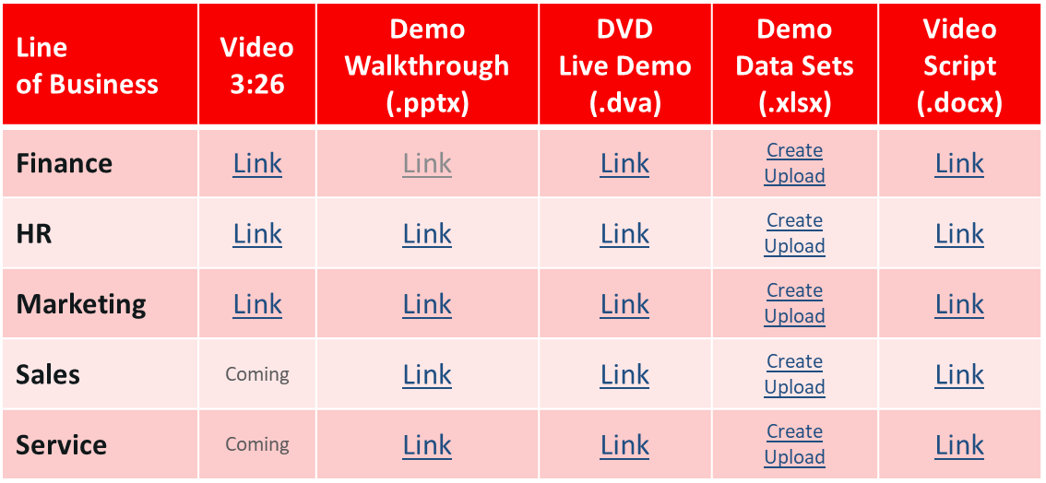

Cross Line of Business Assets

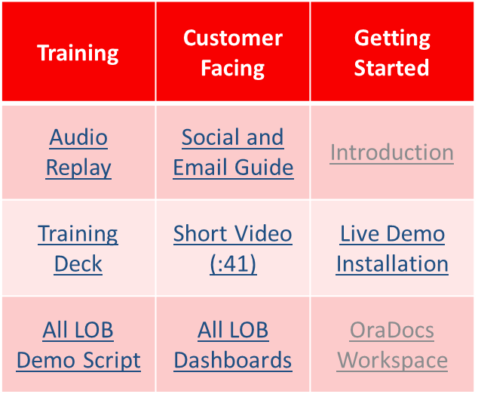

*Use “ADWLOB” to find all videos in video.oracle.*

**Line of Business Analytics Dashboards**

Demo assets are also available to showcase analytics dashboards relevant to specific Line of Business managers.

*<Aditya – this table should summarize the links from the existing LOB demo pages to replace those pages.>*

|  |  |  |  |
| --- | --- | --- | --- |
| **LOB** | **Canned Demo with Script** | **Demo Script Explanation** | **DVA for Live Demo** (Password: welcome)  *Note: Please use the CSV version – the loader database is not publicly accessible at this time* |
| Finance | PPT | MP4 | DVA |
| HR |  |  |  |
| Marketing |  |  |  |
| Sales |  |  |  |
| Service |  |  |  |